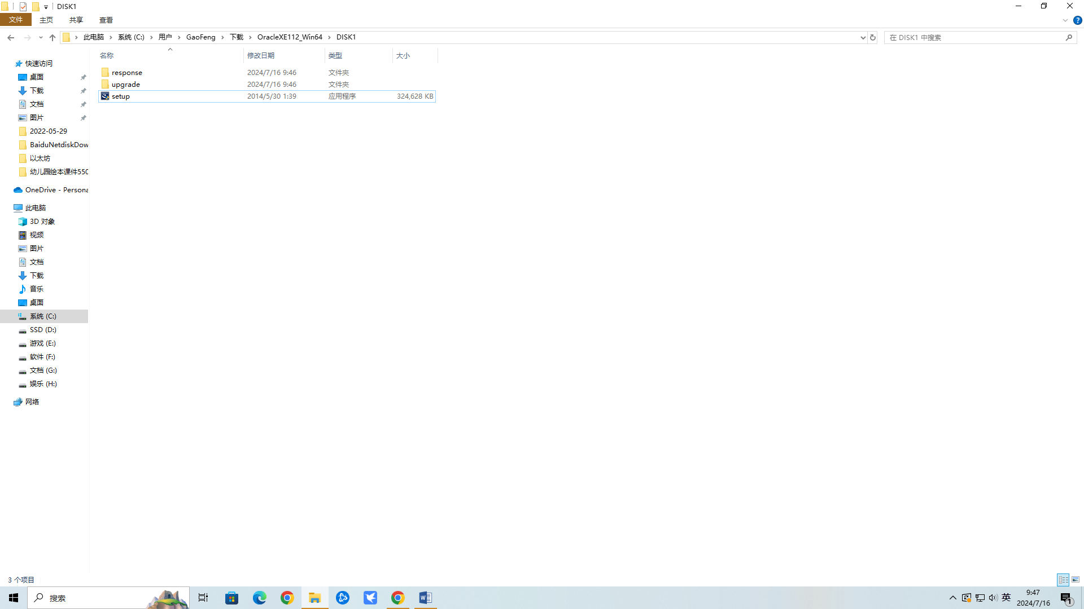

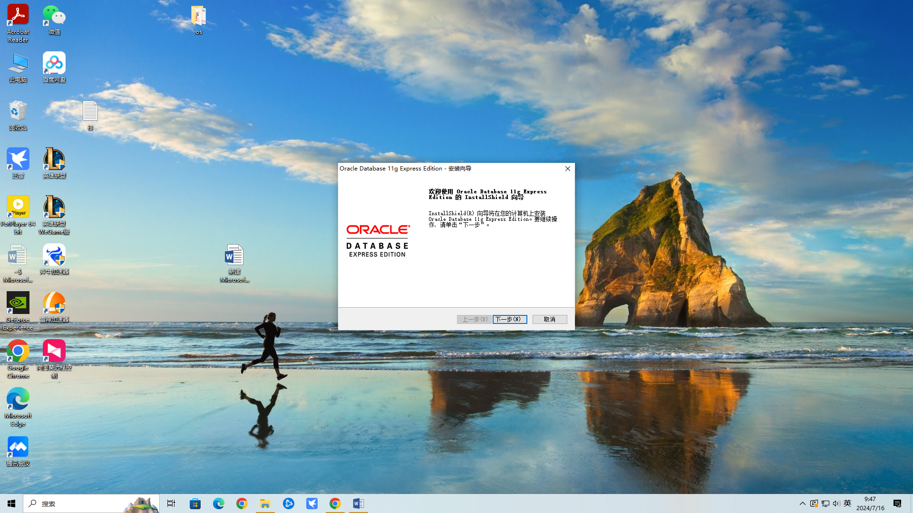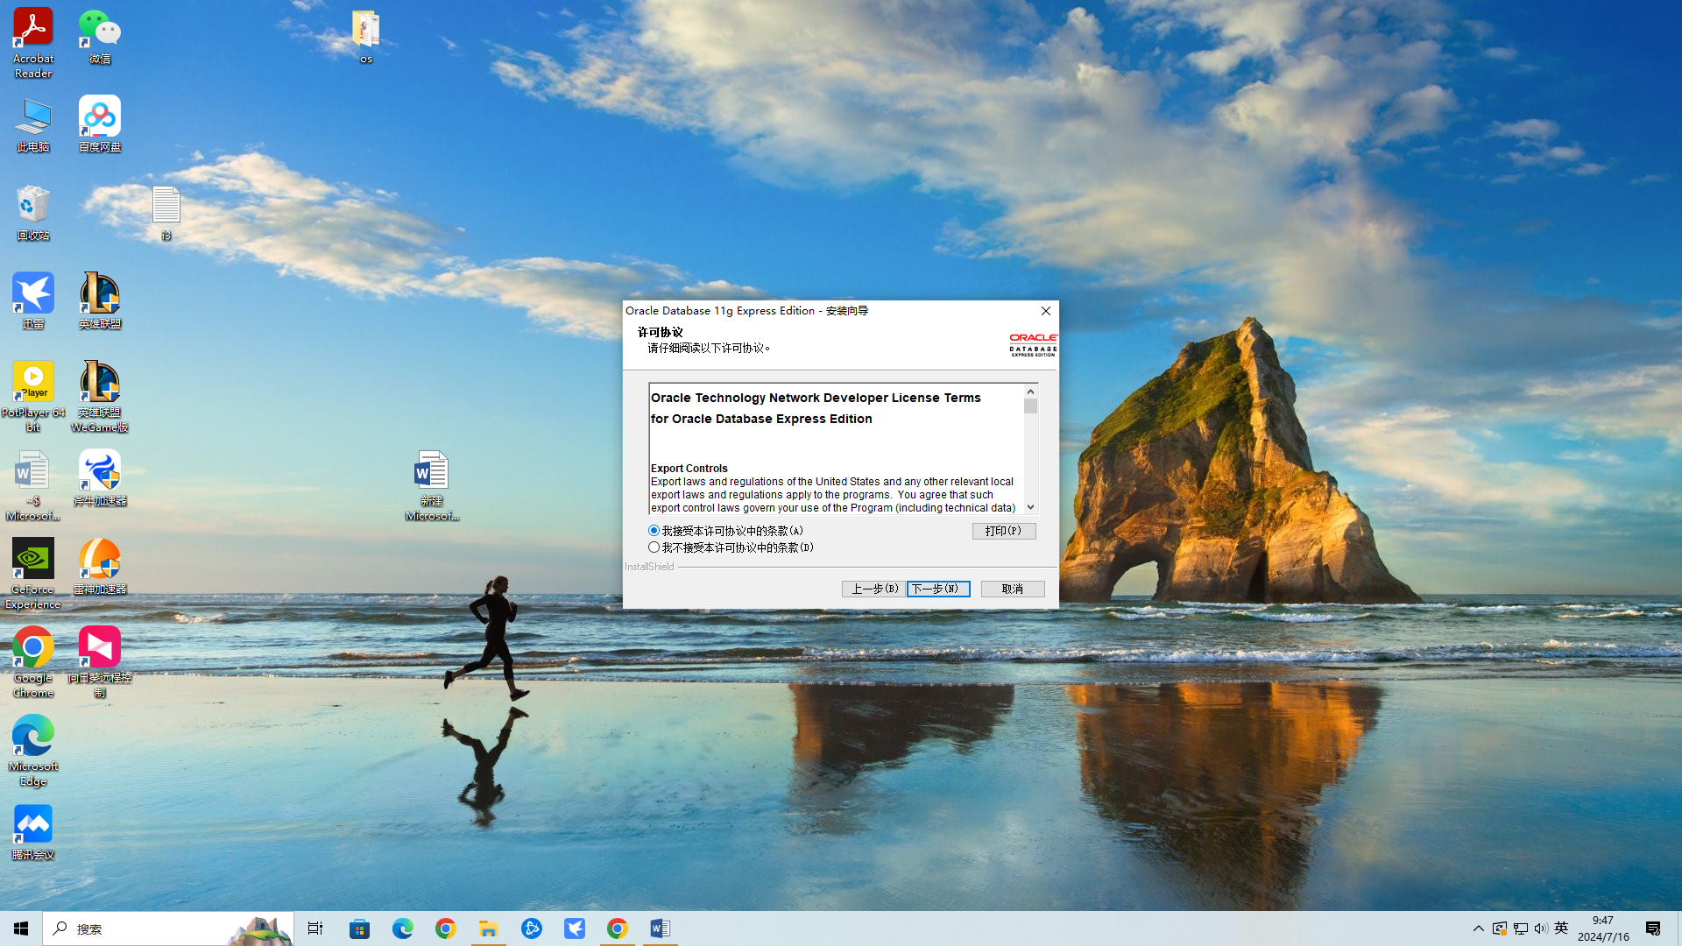

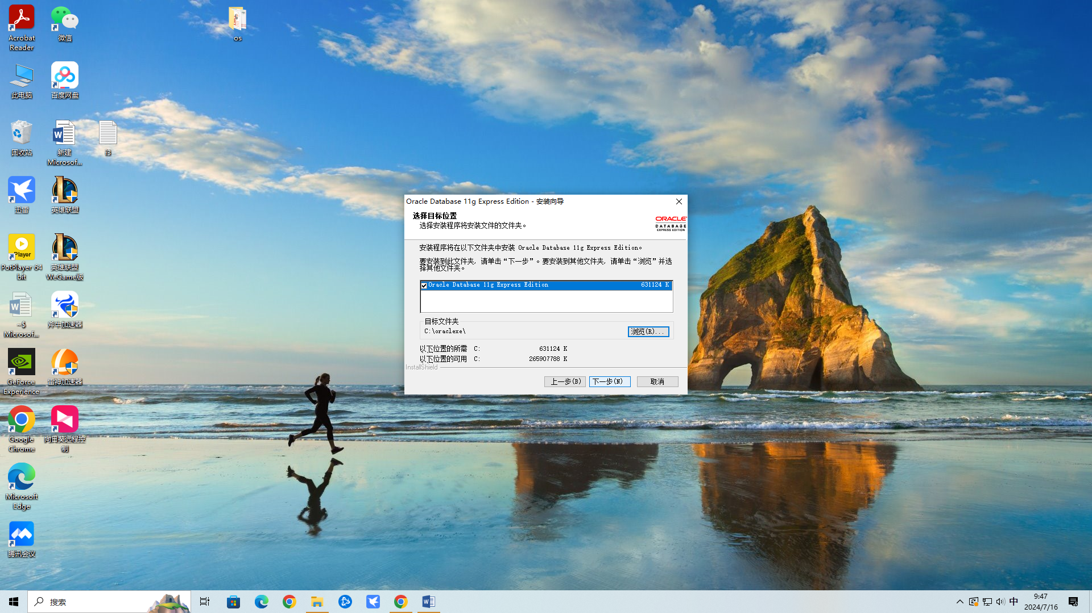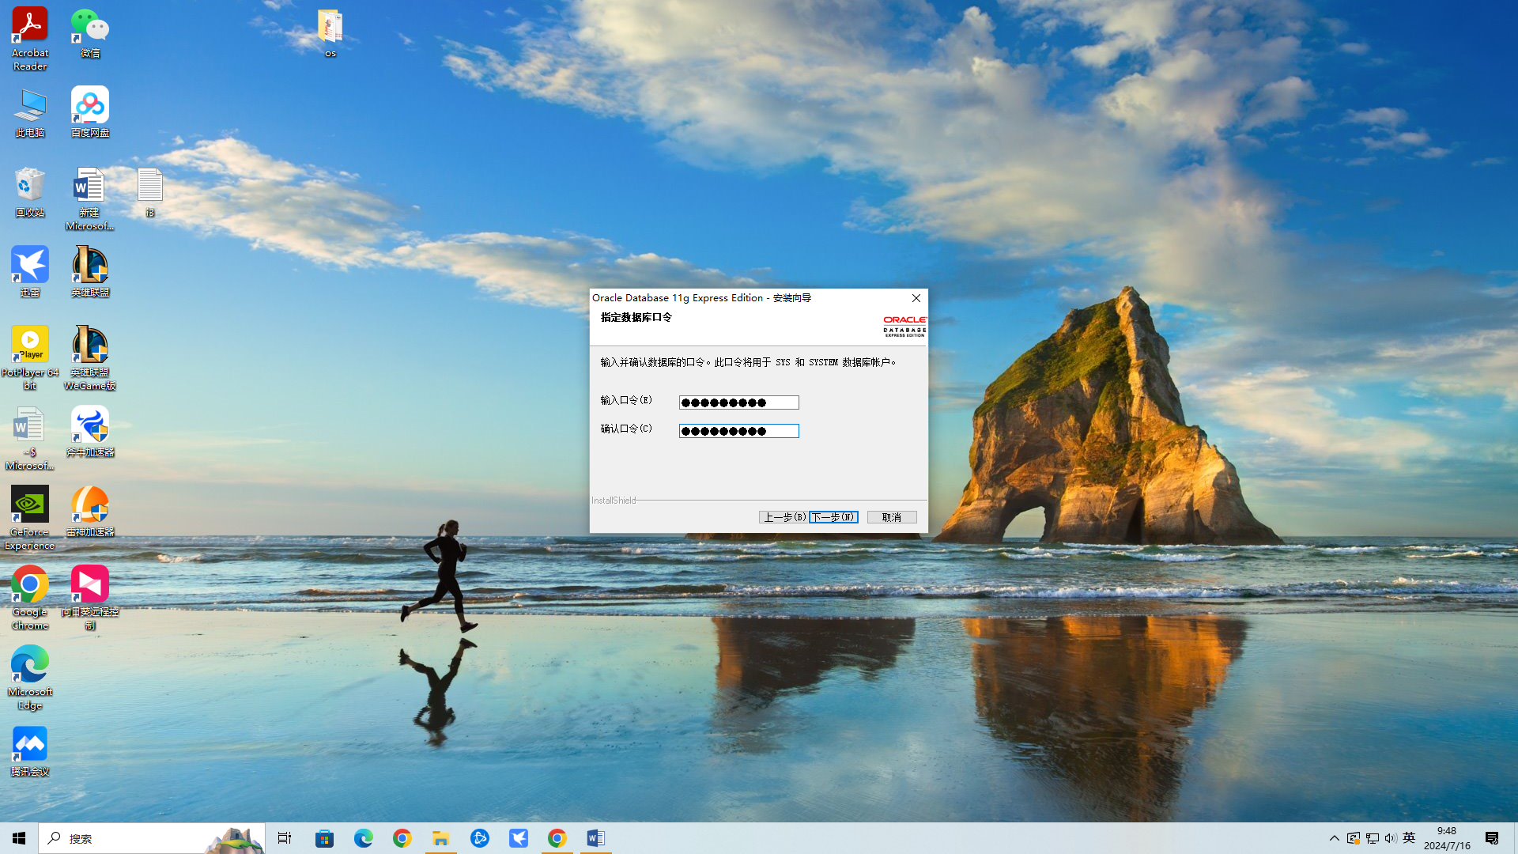631030901

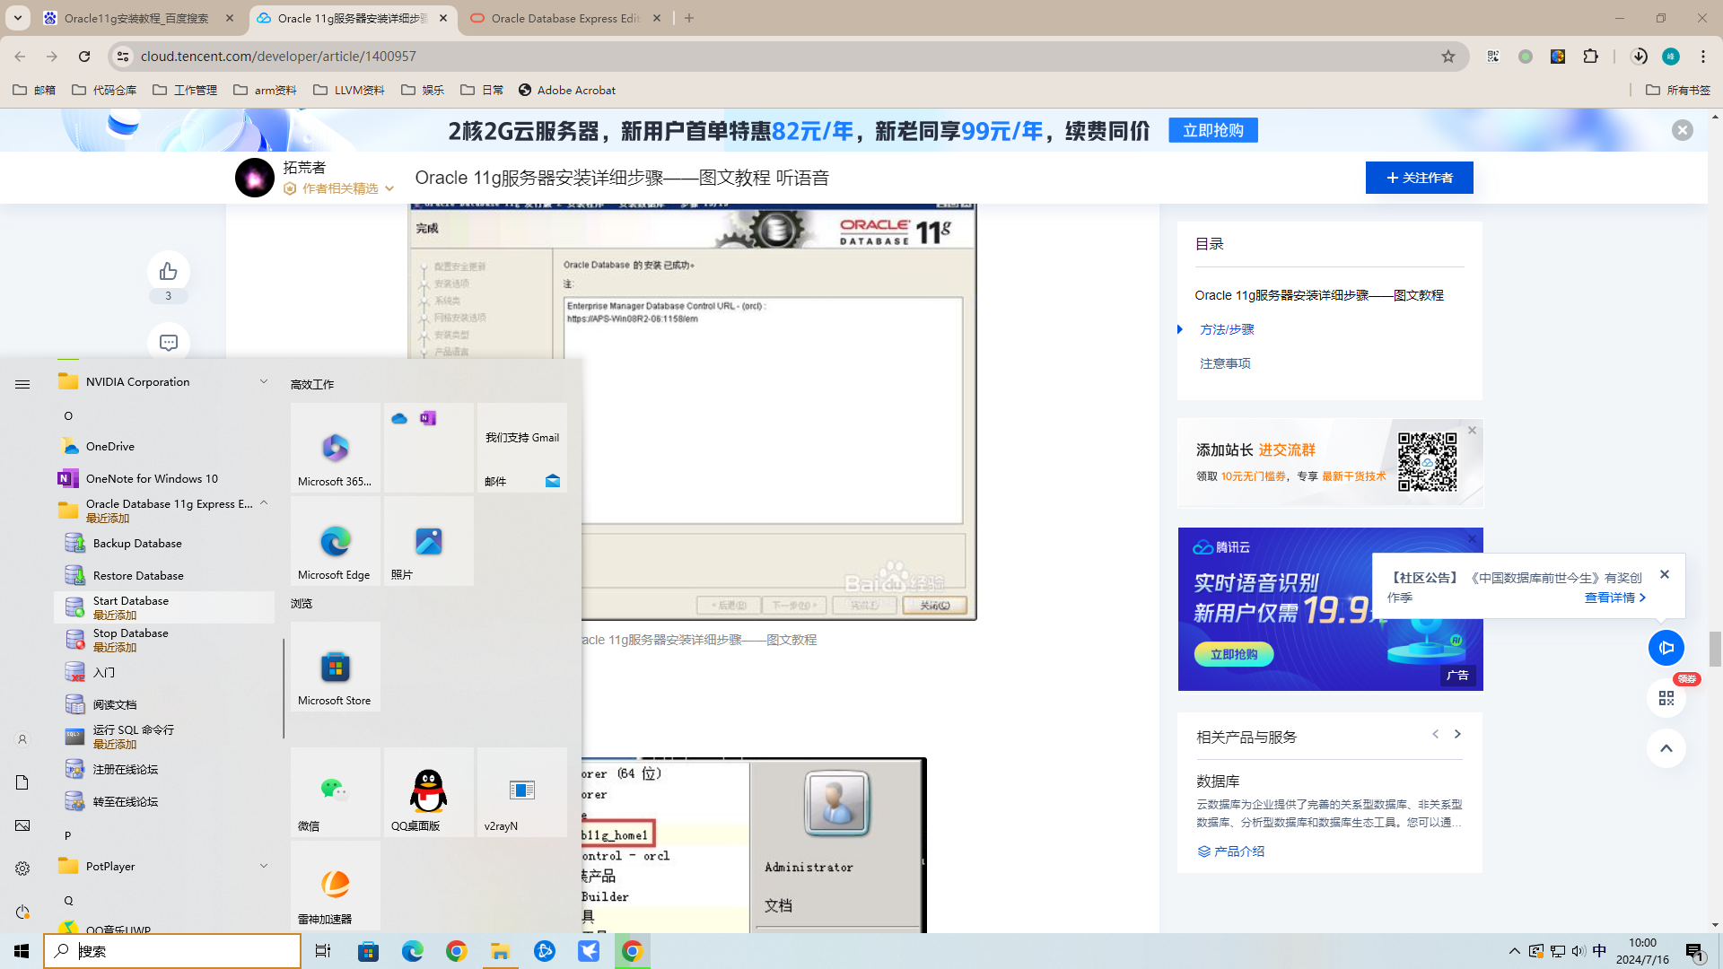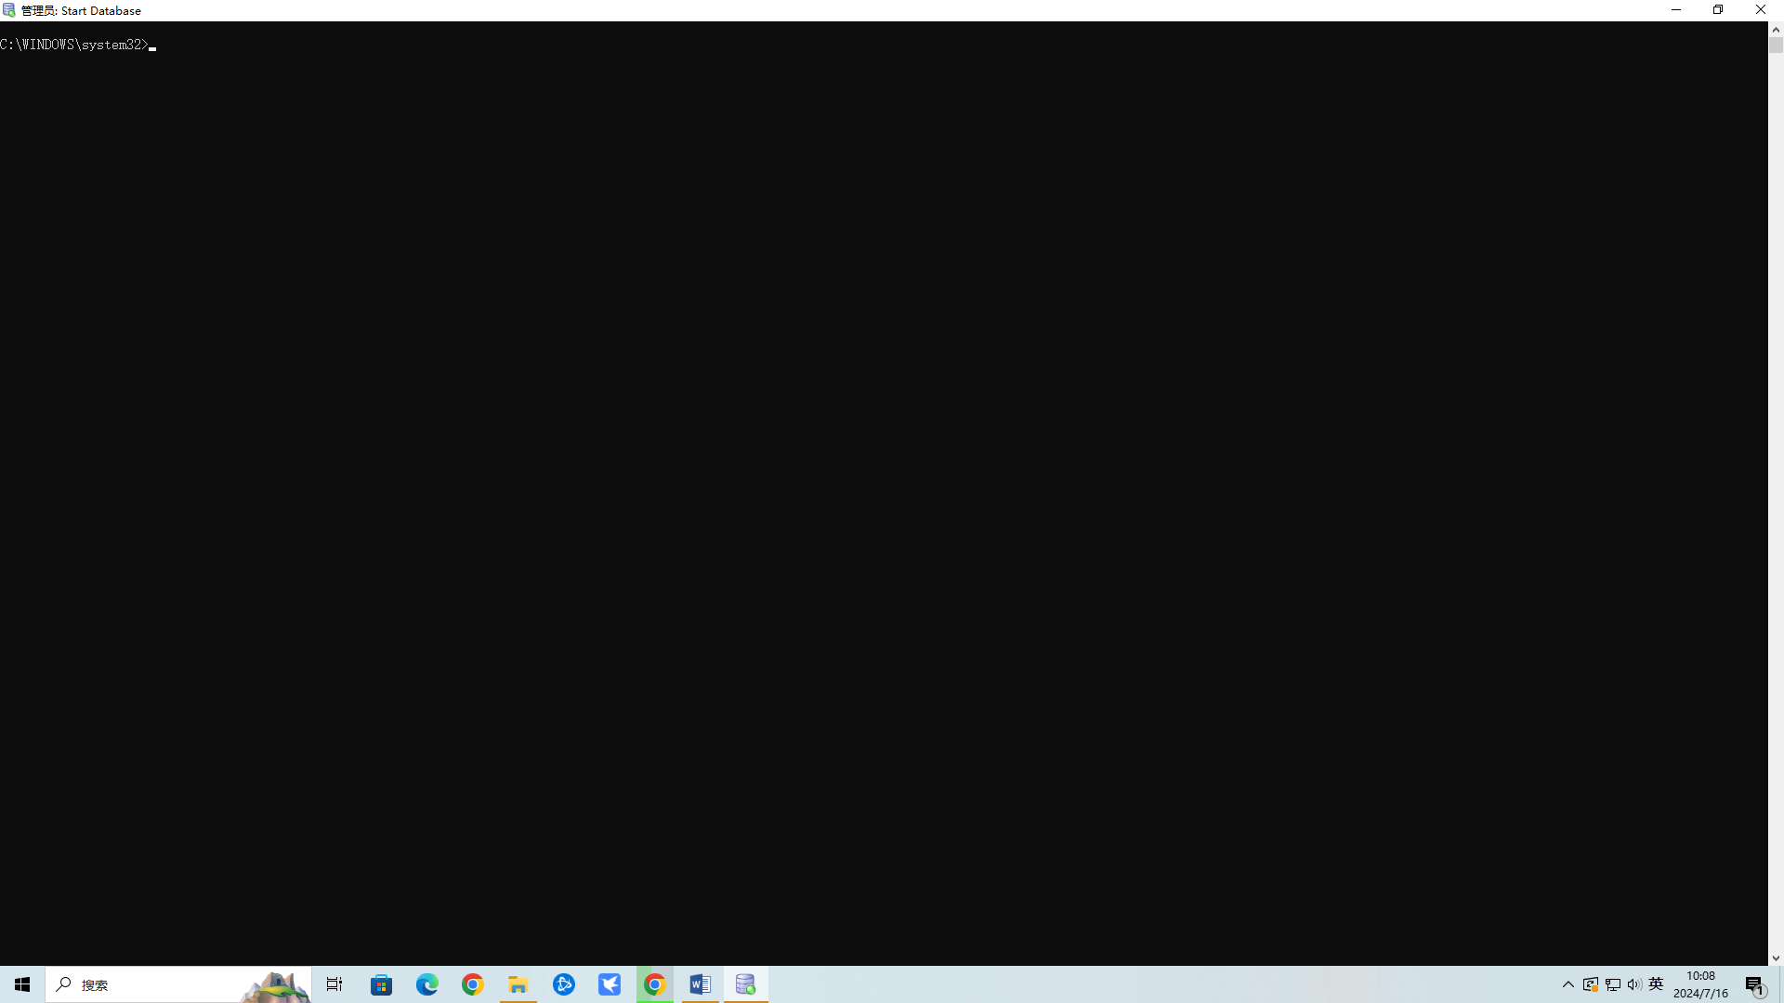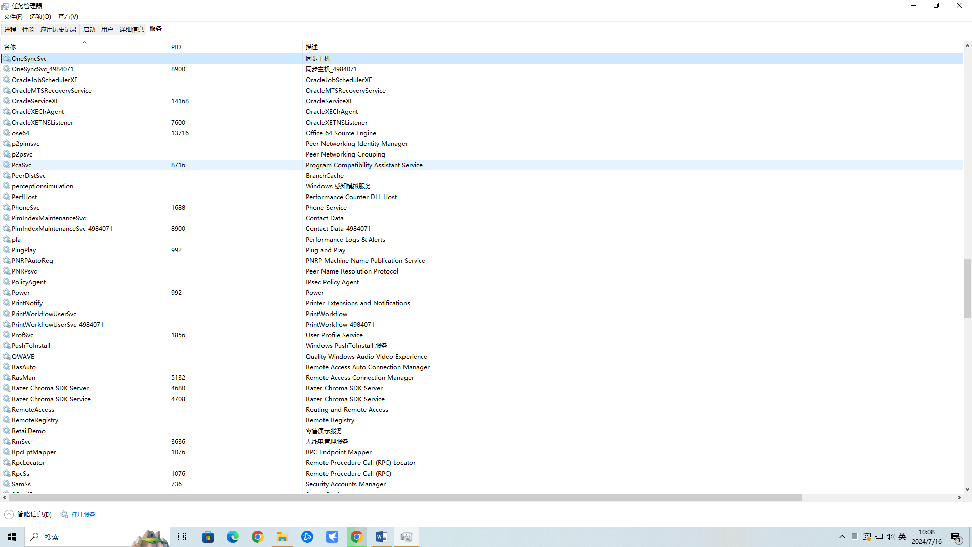

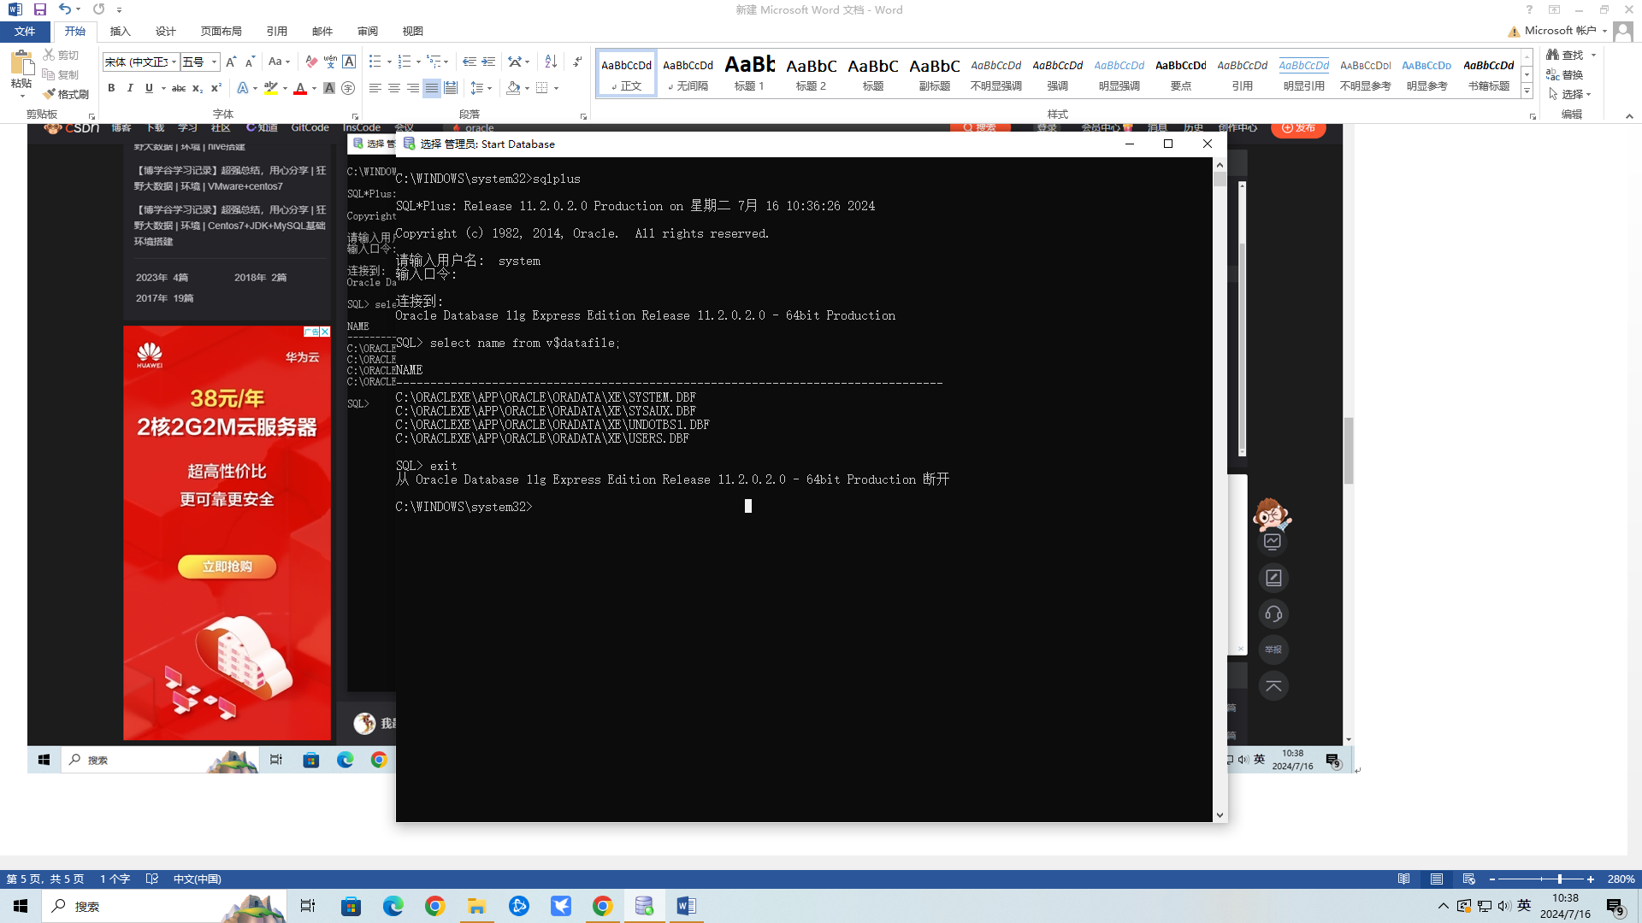

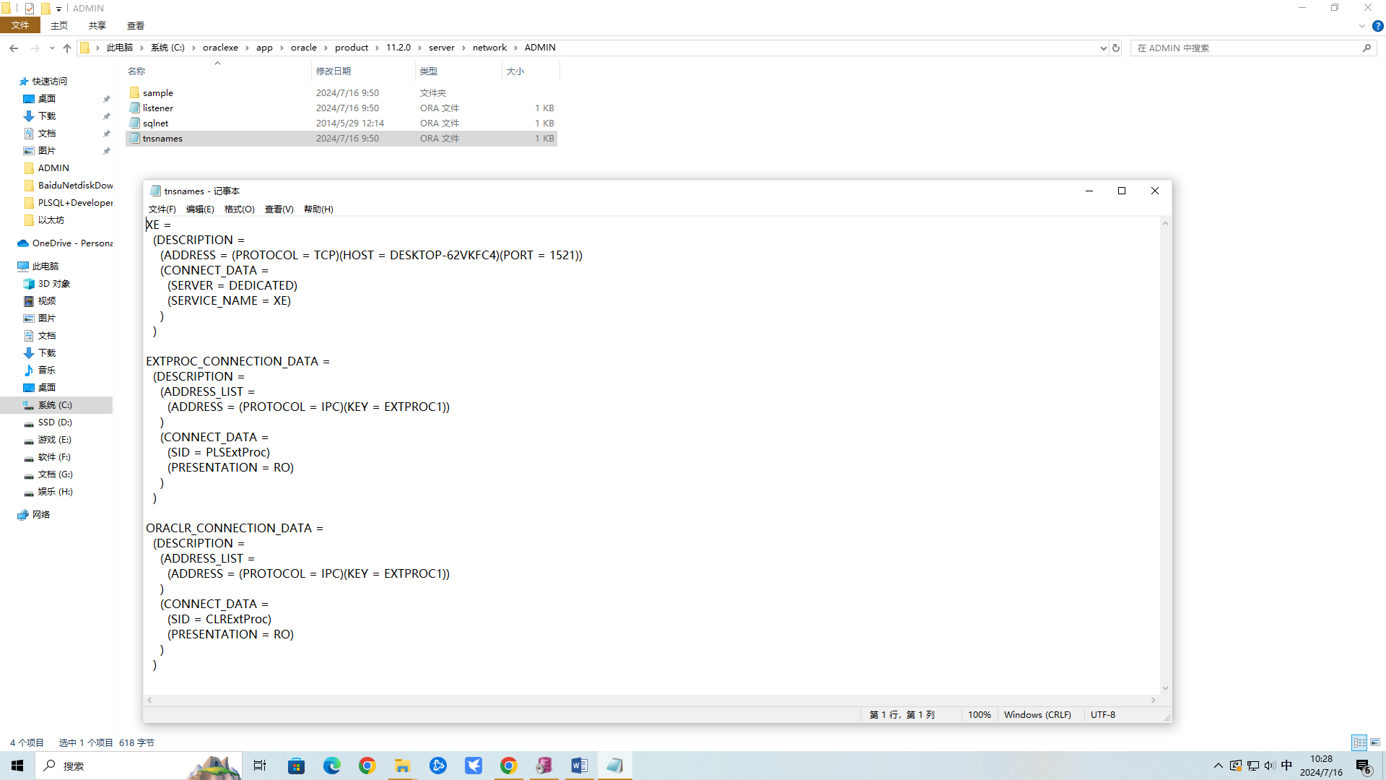

安装plsql工具，注册机进行注册

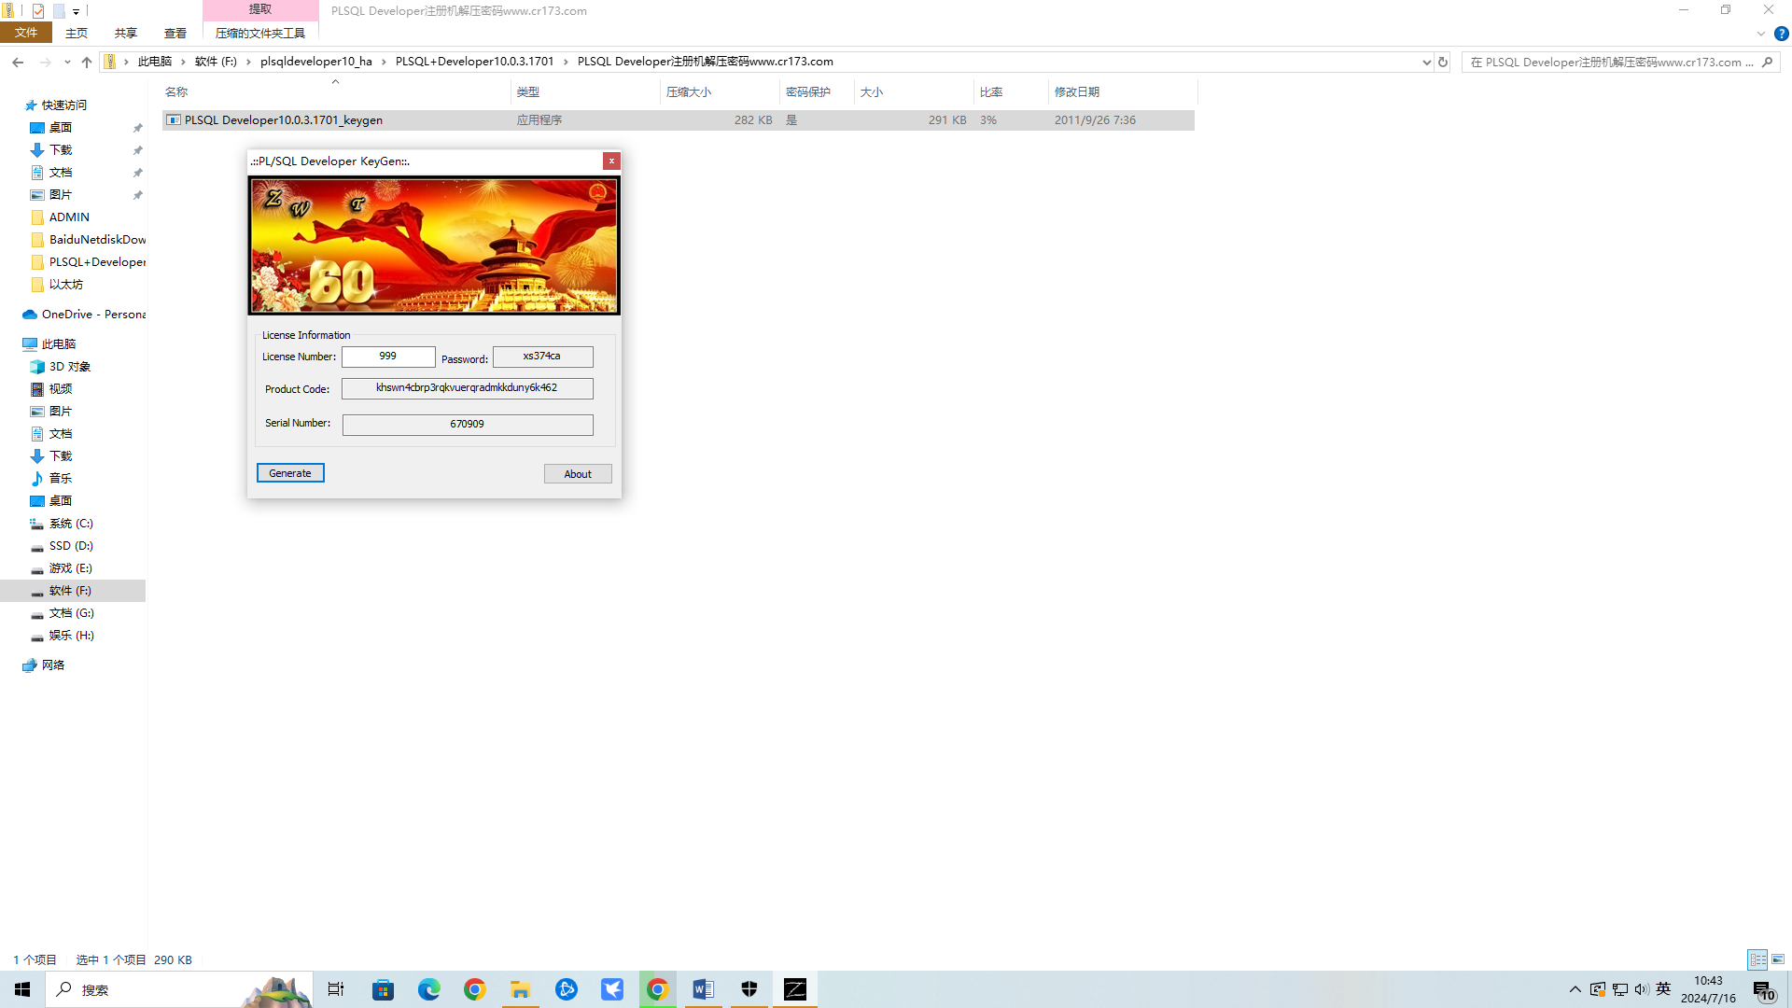

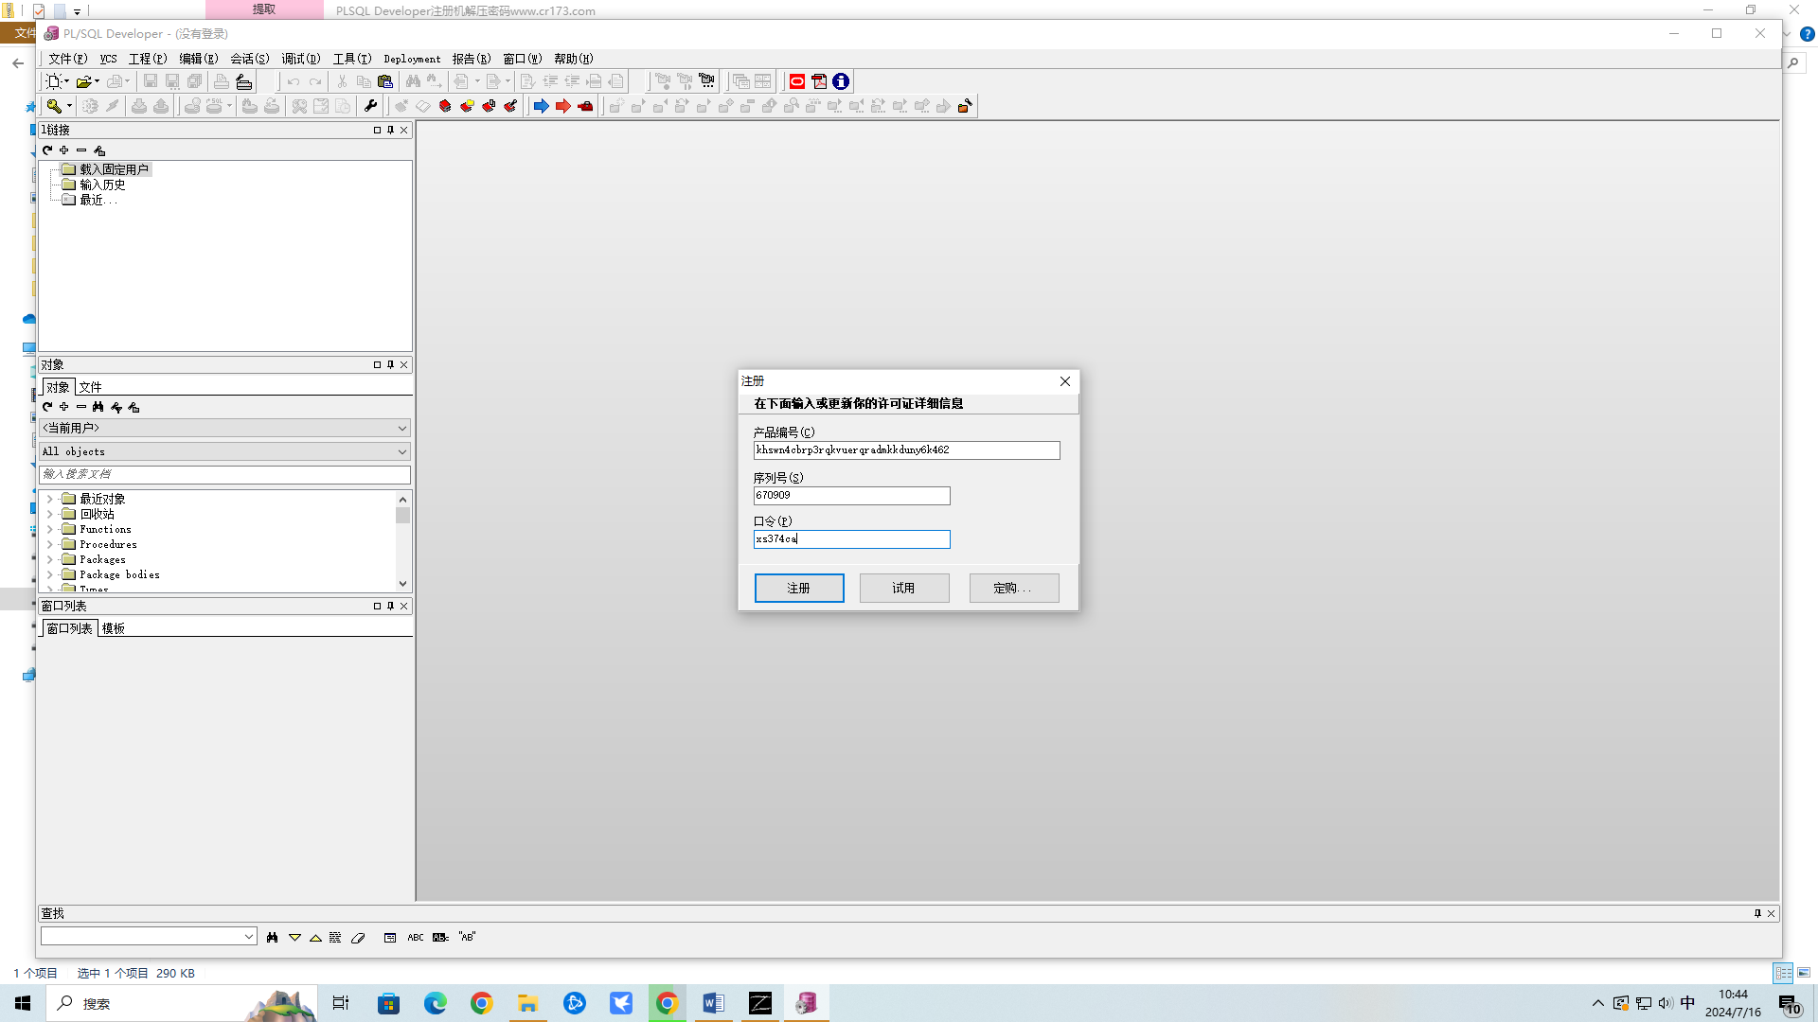

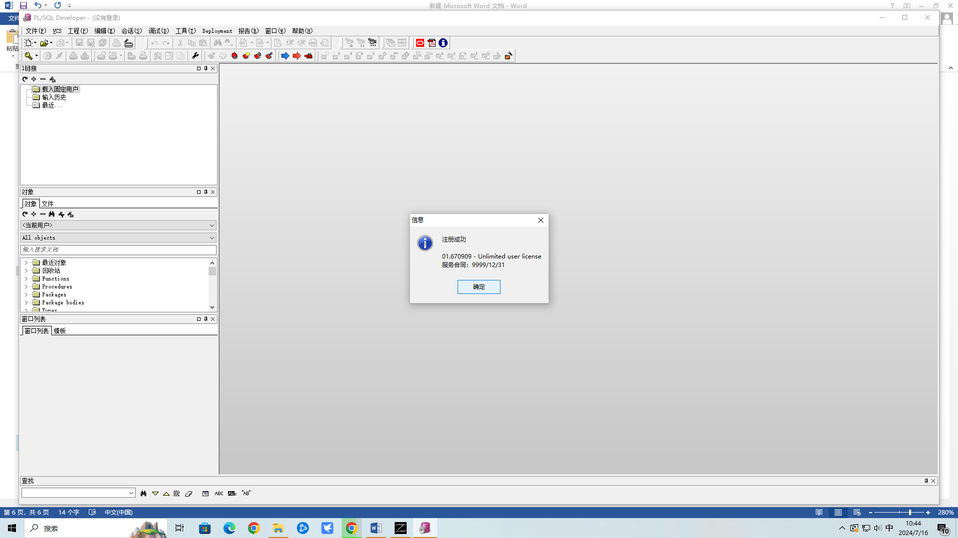

Plsql与oracle11g存在不兼容的问题，需要下载兼容包instantclient-basic-win32-11.1.0.6.0安装(暂时决定不使用plsql)

使用dbeaver链接oracle

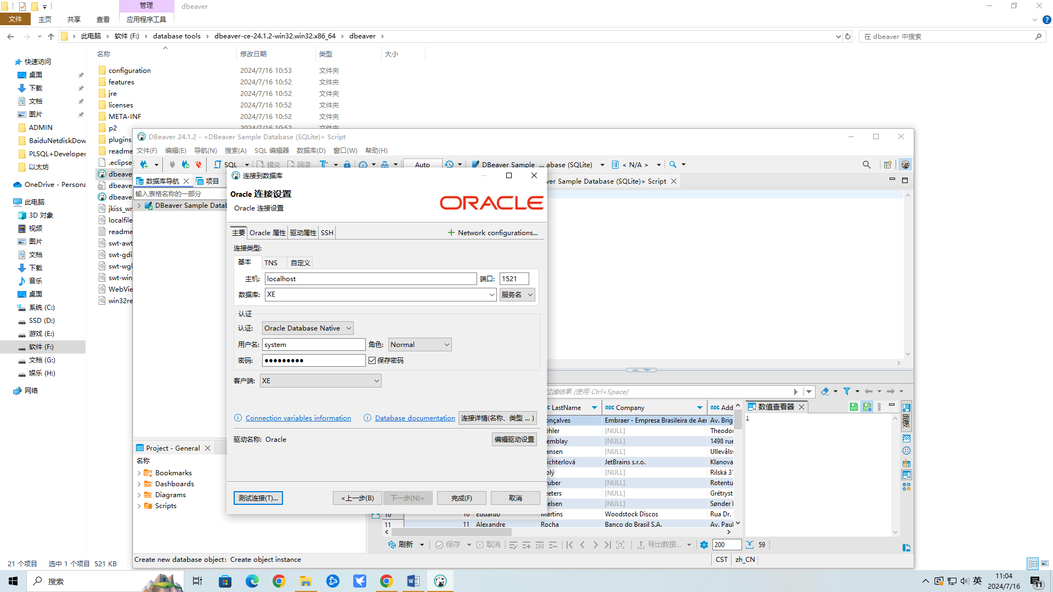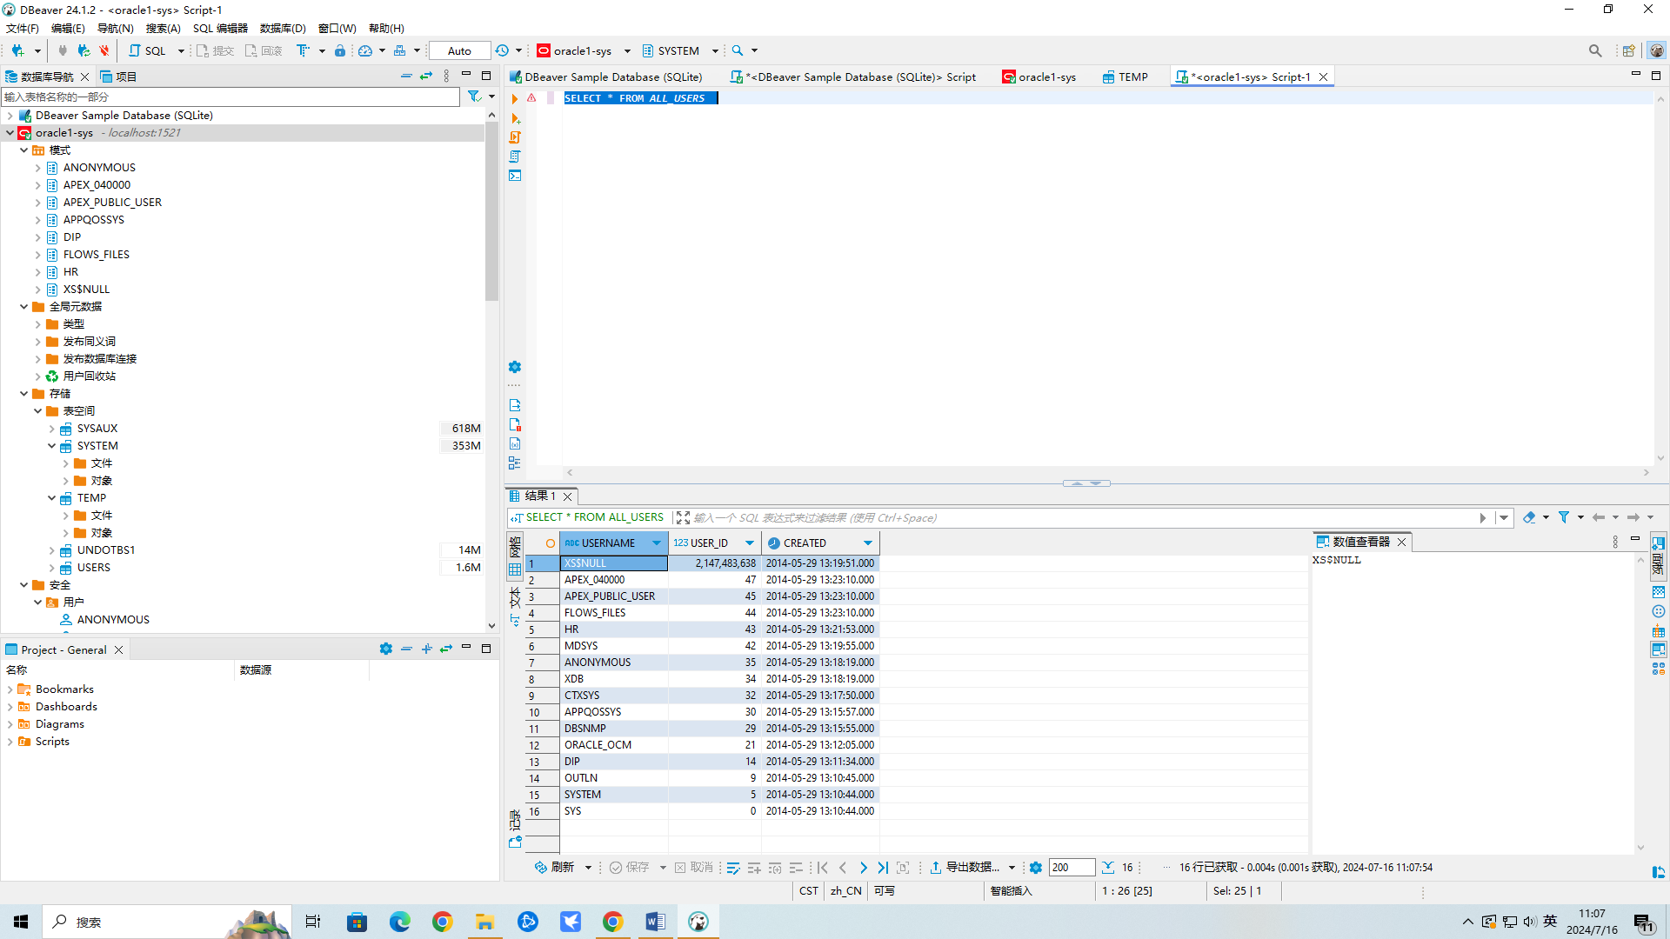

**PLSQL连接Oracle数据库详细教程**

<https://www.zhihu.com/tardis/bd/art/555456954?source_id=1001>

oracle sql server 配置：<https://blog.csdn.net/m0_37769704/article/details/78257611>

# Oracle 安装步骤，附带下载地址 <https://blog.csdn.net/qq_37111953/article/details/81781696>

# oracleXE112Win64位Navicat连接数据库提示错误

[https://blog.csdn.net/happyniceyq/article/details/79858274?utm_medium=distribute.pc_relevant.none-task-blog-2~default~baidujs_baidulandingword~default-1-79858274-blog-52156628.235^v43^pc_blog_bottom_relevance_base2&spm=1001.2101.3001.4242.2&utm_relevant_index=2](https://blog.csdn.net/happyniceyq/article/details/79858274?utm_medium=distribute.pc_relevant.none-task-blog-2~default~baidujs_baidulandingword~default-1-79858274-blog-52156628.235%5ev43%5epc_blog_bottom_relevance_base2&spm=1001.2101.3001.4242.2&utm_relevant_index=2)

# Oracle11g安装教程

<https://blog.csdn.net/testleaf/article/details/111826134>

下载地址：

<https://www.oracle.com/database/technologies/xe-prior-release-downloads.html>

选择： Oracle Database 11gR2 Express Edition for Windows x64

官方说明文档

<https://docs.oracle.com/cd/E11882_01/nav/portal_11.htm>

python资料

<https://docs.qq.com/sheet/DZHNZeWNqVk5hZ0Zq?tab=000001>